Welcome to Lincolnwood High School.

Concessions are located in the cafeteria.
Popcorn and candy may be brought into the gym.
Bottled water and soda may be brought into the gym.
Please keep caps on the bottles, and properly dispose
of the bottles when finished.

Please exhibit good sportsmanship throughout the
tournament. Remember, the gymnasium is an
extension of the classroom.

A trophy will be awarded to the champion of the tournament only

An All-Tournament Team will be selected after the
championship match of the tournament

Bathrooms are located in the cafeteria

Tournament is hosted by Lincolnwood High School Athletic Department

2023 Lincolnwood
Junior Varsity
Volleyball
Tournament

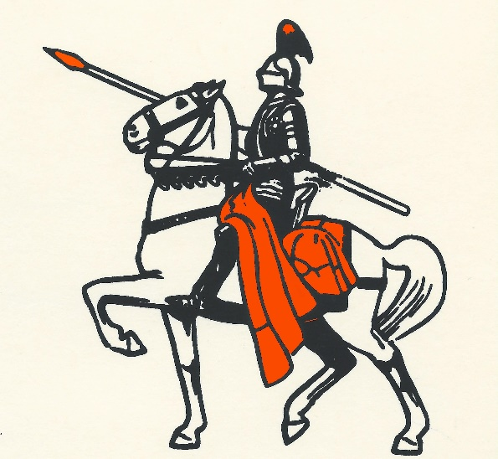

Lincolnwood High School

Lincolnwood Riverton PORTA Carlinville

Greenville Beardstown Hillsboro Litchfield

Hosted by Lincolnwood Athletics
Saturday, October 21st, 2023

Lincolnwood Lancers
1 | MacKenzie Hattenbach | Fr.
2 | Elsa Burenga | Fr.
4 | Macie Daugherty | Fr.
5 | Khloe Klinger | Fr.
7/17 | Alea Wagahoft | Jr.
8 | Sophia Painter | Fr.
9 | Kylie Jack | Fr.
11 | Zarah Guzman | Soph.
14 | Paityn Reagan | Soph.
13 | Yza Apaitan | Fr.
16 | Audrey Germann | Soph.
18 | Kinley Morris | Soph.
19 | Ava Walton | Fr.
20 | Tori Elvidge | Fr.
21 | Camryn Poggenpohl | Fr.
25 | Taryn Love | Soph.

PORTA/A-C Central Lady Jays
2 | Abby Taft | Soph.
4 | Stella Smith | Fr.
6 | Allison Vogel | Soph.
6 | Kinsley Davis | Fr.
7 | Lexi Miller | Soph.
8 | Tara Taft | Jr.
8 | Alexia Glover | Fr.
9 | Rylee Conner | Soph.
10 | Reese Cookson | Soph.
10 | Liberty Powell | Fr.
11 | Bella Smith | Soph.
12 | Bennett Bergman | Fr.
13 | Jaycee Guseman | Fr.
13 | Emma Harris | Fr.
14 | Summer Hill | Fr.
15 | Marley Roberts | Jr.
16 | Carly Breedlove | Soph.
24 | Bailey Dahmer | Soph.
33 | Shae Bell | Jr.
Carlinville Cavaliers
10 | Jada Barkley | Fr.
11 | Braley Wiser | Jr.
12 | Makiah Porteus | Soph.
13 | Taylor Brandenburg | Soph.
14 | Savanna Siglock | Soph.
15 | Ruthie Reels | Fr.
18 | Allie Killam | Soph.
19 | Addie Ruyle | Jr.
24 | Kaitlyn Reels | Soph.
25 | Hallie Gibson | Soph.
33 | Bella Widner | Soph.

Litchfield Lady Panthers
2 | Lexi Logan | Fr.
3 | Melody Ellinger | Soph.
4 | Leighton Warchol | Fr.
6 | Rylee Hamm | Fr.
7 | Ava Becker | Soph.
8 | Chloe Law | Soph.
10/32 | Kyndal Law | Fr.
11 | Brooke Braasch | Soph.
12 | Melanie Pence | Soph.
13/33 | Madilynn Jones | Soph.
16 | Paislei Foss | Soph.
19 | Jaydah Caldwell | Jr.
22 | Megan Boyd | Jr.
27/34 | Alli Frerichs | Soph.
38 | Laurin Hamm | Jr.

Greenville Lady Comets
2 | Jasmyn Wedin | Soph.
4 | Megan Ridens | Jr.
6 | Autumn Lutz | Soph.
10 | Braelyn Andris | Soph.
12 | Shelby Lindley | Jr.
13 | Emma Veith | Soph.
14 | Ava Manhart | Soph.
15 | Keeleigh Valleroy | Soph.
17 | Kaylee Beard | Jr.
19 | Ramzi Stefanisin | Jr.
22 | Haylee Hediger | Soph.
24 | Allie Veith | Fr.
25 | Ella Kleiner | Soph.
31 | Haylee Clark | Soph.

Riverton Hawks
1 | Britnee Walker | Fr.
2 | Macie Baptist | Soph.
3 | Raelyn Moore | Fr.
4 | Brooke Stoll | Soph.
5 | Kadence Pottier | Soph.
6 | Stevi Fuess | Fr.
8 | Kayleigh Flanagan | Fr.
11 | Jenifer Willis | Fr.
12 | Jersey Mulkins | Fr.
13 | Elise Beauchamp | Fr.
14 | Isabella Wilkinson | Soph.
16 | Ryleigh Pygott | Soph.
19 | Lakin Johnson | Soph.

Beardstown Tigers
1 | Andrea Flynn | Soph.
2 | Laetitia Kanda | Fr.
4 | Marielos Vega | Soph.
6 | Makenna Whitlock | Fr.
8 | Wen Zhi (Kiki) Lin | Jr.
9 | Alora Logan | Jr.
11 | Lauren Coats | Soph.
12 | Autumn Bowman | Soph.
13 | Addi McClenning | Soph.
14 | Helen Guadarrama | Jr.
22 | Emely Perez | Fr.
23 | Mia Playan | Jr.
24 | Hallie Lawson | Soph.

Hillsboro Hiltoppers

1 | Addison Compagni | Jr.
2 | Chloe Atkins | Soph.
3 | Briely Kirby | Fr.
4 | Peyton Chappelear | Fr.
5 | Reagan Lentz | Jr.
7 | Brooklyn Fisher | Soph.
8 | Brooklyn Kirby | Soph.
10 | Kearstynn Davis | Soph.
11 | Peyton Christian | Fr.
12 | Makaela Martin | Jr.
13 | Albany Kindernay | Fr.
14 | Delaney Adams | Fr.
15 | Karsyn Greenwood | Fr.
16 | Sadie Houchlei | Soph.
17 | Jossalyn Kimbro | Soph.

Lincolnwood JV Tournament
Saturday, October 21st , 2023

High School Grade School
 | POOL A |  |  | POOL B
1 | Lincolnwood |  | 1 | Greenville
2 | Beardstown |  | 2 | PORTA
3 | Hillsboro |  | 3 | Litchfield
4 | Riverton |  | 4 | Carlinville

Time | Game
9:00 | 1 | 1 vs. 3
9:45 | 2 | 2 vs. 4
10:30 | 3 | 1 vs. 4
11:15 | 4 | 2 vs. 3
12:00 | 5 | 3 vs. 4
12:45 | 6 | 1 vs. 2

Time | Game
1:30 | 7 | Pool B 2nd vs. Pool A 2nd
2:30 | 8 | Pool B 1st vs. Pool A 1st

High School Gym Grade School Gym

Time | Game
1:30 | 7 | POOL A 4th vs. Pool A 4th
2:30 | 8 | Pool B 3rd vs. Pool A 3rd

*Warm-Ups will be 4-4 only. After all teams have played it will be 3-3 only. Serving must be done during your full court time. Home team will be listed first on schedule. We will have a scorebook keeper in the high school gym. In the grade school gym, the home team must supply a bookkeeper to sit at scores table and the visiting team should supply a libero tracker.

Pool Play will be 2 games to 21 only. Cap of 25.
Cross-over games will be best 2 out of 3 to 25. 3rd is first to 15. Championship game only all 3 games will be to 25. Must win by 2 with no cap.
Pool places determined by most wins, then points allowed, then head to head.
Games will run ahead whenever possible. Be ready to play!

