SPONSORING PROGRAM PARTNERS:

Micks’s Auto Body & Car Wash
Pope Seeds

To find Lincolnwood athletic schedules and digital programs for all home games scan the QR code below:

Lincolnwood
Lancers
Basketball

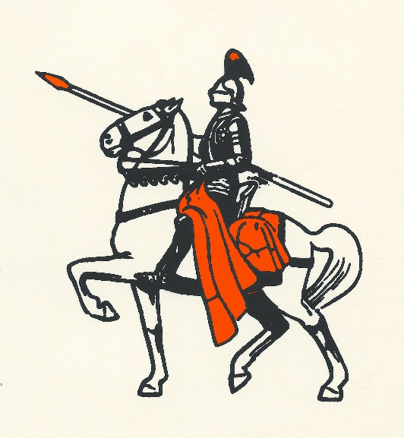

PREVIEW NIGHT

Friday, November 10, 2023
Hosted by Lincolnwood High School

Lincolnwood Lancers
Boys Basketball Roster
Number Name Height Year
0 | Liam Page | 5’9” | Fr.
1 | Cooper Poggenpohl | 5’11” | Jr.
2 | Jonah Elvidge | 6’1” | Jr.
2 | Bryce Cowdrey | 5’10” | Fr.
4 | Zach Sale | 5’11” | Soph.
4 | Zane Whalen | 5’11” | Fr.
10 | Brady Schmedeke | 6’2” | Sr.
10 | Aiden Sheedy | 5’10” | Soph.
12 | Tucker Armentrout | 6’0” | Soph.
14 | Jared Klein | 6’3 | Jr.
14 | Charlie Clavin | 5’10” | Fr.
20 | Donny Daugherty | 5’10” | Jr.
22 | Luke Armentrout | 6’3” | Soph.
24 | Brayden Morris | 6’1” | Jr.
30 | Kennady Cook | 6’0” | Jr.
30 | Luke Pope | 5’10” | Fr.
32 | Austyn Hefley | 5’10” | Fr.
34 | Drew Gilpin | 6’2” | Jr.
40 | Karson Hayes | 6’2” | Jr.
40 | Keaton Thomas | 6’1” | Fr.
42 | Izeck Matli | 6’0” | Soph.
44 | Gabe Armentrout | 6’2” | Sr.
44 | Max McClellan | 6’5” | Jr.
Head Coach: Matt Millburg
Asst. Coach: Josh Johnson, Drew Logan, Alex Nicol, Bill Krager

Lancer Cheerleaders:
Seniors: Kaylee Gerlach, Ariana McDaniel
Juniors: Callie Beeler, Abby Norris, Kirsten Pope, Alea Wagahoft
Sophomores: Taryn Clarke, Braylin Crawford, Rian Deardorff, Kinley Morris
Freshman: Zoey Hunt, Hannah Jostes, Khloe Klinger, Camryn Poggenpohl
Coach: Bev Lipe
Asst. Coach: Shannon Mitchelar, Samantha Bourke

Lincolnwood Lancers
Girls Basketball Roster
Number Name Height Year
2 | Jolee Downs | 5’5” | Fr.
4 | Eliana Nudo | 5’4” | Soph.
5 | Sophia Foster | 5’9” | Jr.
10 | Sophia Painter | 5’8” | Fr.
11 | Carly Armentrout | 5’8” | Soph.
12 | Leah Anderson | 5’2” | Soph.
14 | Tori Elvidge | 5’11” | Fr.
15 | Chelsie Anderson | 5’7” | Sr.
22 | Taryn Millburg | 5’3” | Sr.
25 | Taylor Lush | 5’9” | Jr.
31 | Lilly Terneus | 5’9” | Jr.
40 | Jackie Carrillo-Tomas | 5’5” | Soph.

Head Coach: Justin Millburg
Asst. Coach: Courtney Bounds

The Panhandle School District promotes good sportsmanship at all times by student-athletes, coaches, and spectators.
We request your cooperation by supporting the participants and officials in a positive manner.
Profanity, derogatory comments, or other intimidating actions directed at officials, student-athletes, coaches, school representatives, and/or others in attendance will not be tolerated and will be cause for removal from Panhandle School District grounds and contest areas.

