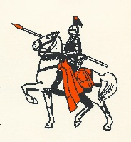 WARNING MESSAGE 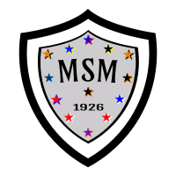
The Panhandle School District always promotes good sportsmanship by student-athletes, coaches, and spectators. We request your cooperation by supporting the participants and officials in a positive manner. Profanity, derogatory comments, or other intimidating actions directed at officials, student-athletes, coaches, school representatives, and/or others in attendance will not be tolerated and will be cause for removal from Panhandle School District grounds and contest areas.
LET THE OFFICIALS OFFICIATE
LET THE COACHES COACH
LET THE PLAYERS PLAY
#PANHANDLE2PRIDE
- Lincolnwood Athletics Website

